

Creating and designing a simple 2d game

Home Assignment



November 28, 2017

McasT

Darren Buttigieg

**Question 1:**

A)

* Two Game engines are: Unity and Unreal Game engine
* Unity is Simple to use and since this is my first game that I am developing, Unity was the perfect choice.
* Unity has a free version, while other game engines would need some money to use them.
* Unity has a wider range of platforms that you can use .This helps that you can try developing games on different OS.
* Unreal game engine is a more sophisticated game engine and is more used by developers who already have some experience developing games.

B)

* Two programming languages are: C# and C++.
* C# has a vast variety of libraries that can help you code more efficiently.
* C# goes in conjunction with Object-orientated programming and programming concepts.
* We use C# because of VS integration.
* C# is a safe type of programming language and does not allow the user to use code that can alter the system.

For example :( Direct Data Manipulation)

**Question 2:**

2A)

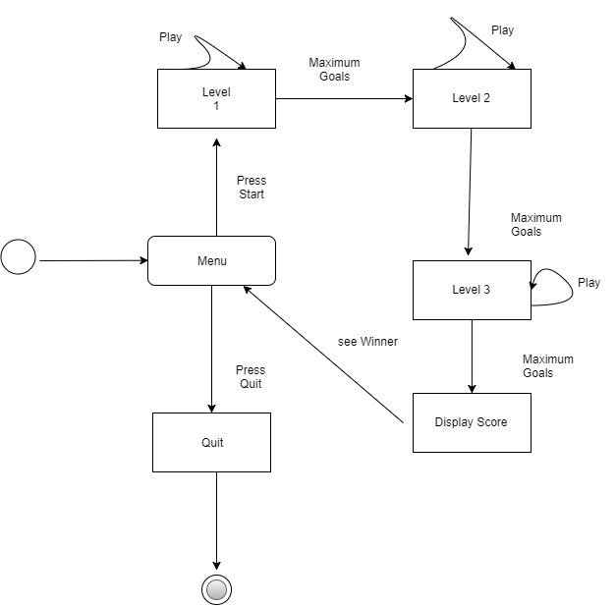

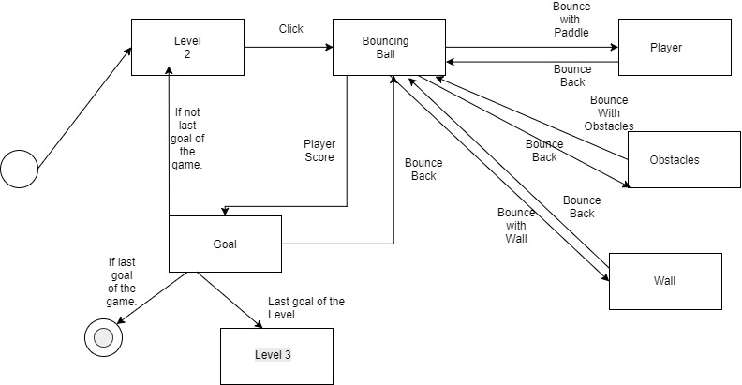2B)

**Question 3:**

Videos, audio, images and other types of multimedia files take up a lot of space in the hard disk. Compressing these files will make them smaller and can be easier to share. When you compress a file, the unnecessary and repetitive information are being removed. There are two main types of file compression, lossless and lossy. The usage of compressed files can free up valuable space on a hard drive, or a web server. Some files like MP3 cannot be compressed further since they are already compressed.  Compressing files before sending them over the Internet can reduce the amount of time it takes by a considerable margin.

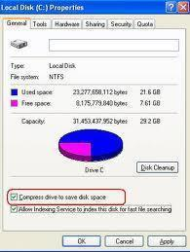

**References:**

* Pluralsight.com. (2017). *Unreal Engine 4 vs. Unity: Which Game Engine is Best for You?.* [online]

Available at: <https://www.pluralsight.com/blog/film-games/unreal-engine-4-vs-unity-game-engine-best> [ Accessed 30 Nov. 2017].

* Computer Knowledge. (2017). *What is File Compression? – Computer Knowledge*. [online]

Available at: <https://www.cknow.com/cms/articles/what-is-file-compression.html> [Accessed 30 Nov. 2017].

* MCAST Lecturer’s Notes